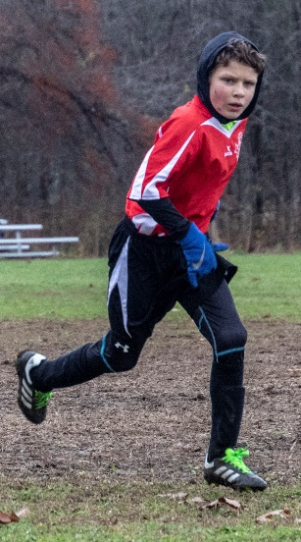 Images of Greyson Playing Soccer- November 10, 2018

On Saturday, the 10th, we traveled down to Harvard, MA, to see grandson Greyson play another game of organized soccer. This year Grey is in 4th grade and in a 3-4 grade Stow team competing with various area town teams in the Massachusetts Nashoba Valley Youth Soccer League. Grey’s team was 6-0 going into today’s game and won 4-0 under wet, very windy, and cold weather. With a 4-2 win the following Sunday, his team went undefeated at 8-0. Congratulations on the successful soccer season and to Grey for his powerful performances. Makes a grandfather proud!

And for the photos, click [Greyson – Soccer/2018 -II](https://photos.app.goo.gl/wJLdCAUKqwMnpubd9).